Name: Krishnaraj Prashant Thadesar. Class: F.Y B.Tech Division 9. Batch: I3.



Roll No.: 109054 Expt. No. 2 .

Performed on: 06/09/21 . Submitted on: 07/09/21 . Teacher’s Sign.: .

**DETERMINATION OF COEFFICIENT OF FRICTION BETWEEN FLAT BELT AND PULLEY**

***Purpose of the experiment:***

To introduce the concept of frictional force, Coulomb’s laws of friction, belt friction and to determine coefficient of friction between flat belt and pulley.

***Instruments:***

1. Belt friction apparatus
2. flat belt
3. weights and hangers

***Theory:***

Friction:

To stop a moving object, a force must act in the opposite direction to the direction of motion. For instance, if you push your book across your desk, the book will move. The force of the push moves the book. As the book slides across the desk, it slows down and stops moving. The force that opposes the motion of an object is called friction.

* It always slows down motion
* It always acts at the surface of contact
* It always opposes motion
* Passive, self-adjusting force, that impends motion

Types of Friction:

1. *Kinetic Friction:* It is defined as the force that acts between moving surfaces. It is further divided into rolling and sliding friction.
2. *Static Friction*: It is defined as the frictional force that resists force applied to an object. The object remains at rest until the force of static friction is overcome. The Maximum value of the static friction is called the limiting friction.

Angle of friction:

Angle of friction is the angle formed between the resultant of normal and force of friction and the normal. If the reaction normal to the surface is denoted by N, and the frictional force along the surface at the instant, motion is just impending is denoted by Fmax, then the angle of friction is defined as:



$λ=\tan^{-1}\left(\frac{F_{max}}{N}\right){.}$

Coulomb’s Law of Friction:

*“The contact force comprises of a normal component $F_{n}$, perpendicular to the contact plane between the two solids, and a tangential component $F_{t}$, belonging to the contact plane. The frictional force F acts along the tangent plane at the surface of contact and the opposes movement of bodies in contact”*

The slip between the two solids occurs if Fn and Ft verify the proportionality relationship:

$$F_{t}=μ⋅F_{n}$$

where μ is the coefficient of friction that characterizes the condition of the two surfaces in contact. As long as the force Ft is less than μ Fn, sliding does not occur, and is referred to as adhesion between the two solids.

Belt friction:

The force of friction acting between the belt or cable and the pulley in a system is known as belt friction. In this system the belt or cable is wrapped around a pulley or any cylindrical surface.

The pulley of radius r is stationary. A belt passes around the pulley subtending an angle, which is known as 'Angle of Lap'. T1 is the tension on tight side and T2 is the tension on slack side. Both these forces are such that motion of the belt is impending in the direction of T1.

Hence forces acting on a small infinitesimal element have to be considered and them total effect over the entire arc has to be obtained. The final equation upon derivation obtained is:

$$\frac{Tight tension}{Slack tension}=\frac{T1}{T2}=e^{µβ}$$

***Procedure:***

*Case 1: Determination of coefficient of friction µ by maintaining angle of lap β constant.*

1. Adjust the angle β by rotating the graduated disc such that desired angle β is obtained. Fix the handle tightly.
2. Make sure that both the belt and pulley surfaces are clean.
3. By holding the belt place a known weight, T1 on one side (slack side), adjust the weights T1 on tight side such that the belt just starts sliding over the pulley.
4. Repeat this procedure for five different values of T2 and tabulate the results.

*Case 2: Determination of coefficient friction µ by maintaining T2, that is tensions on slack side constant.*

1. Perform the experiment in a similar manner as in case 1 except in this case, the value of T2 is constant, and the value of β varies.
2. Keep T2 constant and vary the value of angle of lap β.
3. Repeat the procedure and tabulate the results for five different values.

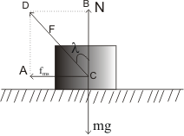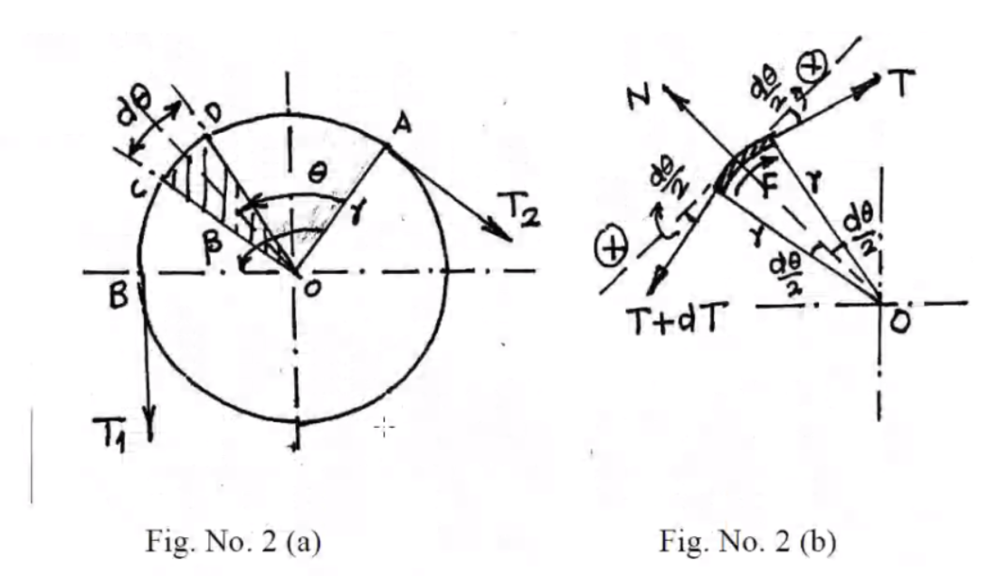

Figure 1. Angle of Friction

# *Observations and Calculations: -*

|  |  |  |  |  |  |  |  |  |
| --- | --- | --- | --- | --- | --- | --- | --- | --- |
| Sr.  No. | Case -1, β = | | | Sr.  No. | Case-2, T2= | | | |
| T2(N) | T1(N) | µ | β (deg) | β (rad) | T1 (N) | µ (N) |
| 1. |  |  |  |  |  |  |  |  |
| 2. |  |  |  |  |  |  |  |  |
| 3. |  |  |  |  |  |  |  |  |
| 4. |  |  |  |  |  |  |  |  |
| 5. |  |  |  |  |  |  |  |  |
|  | | µave = |  |  | | | µave = |  |

*Note: Students are instructed to do all the necessary calculation on separate sheets and record the result.*

***Graphs:***

*Case-1: Draw a graph with values of T2 on X axis and that of T1 on Y axis. The scale chose should be the same on both the axes. The graph will be a straight line passing through origin.*

*Case-2: Draw a graph with value of β (rad) on X axis and loge T1 on Y axis. The graph will be a straight line, with Y intercept as loge T2. The slope of the straight line will be the value of µ.*

Note: Students are instructed to draw the graphs on separate paper and record the result.



***Result*:**

|  |  |  |  |
| --- | --- | --- | --- |
| Case (1) | | Case (2) | |
| µ (Experimental) | µ (Graphical) | µ (Experimental) | µ (Graphical) |
|  |  |  |  |
| Average value of µ = | | | |

Hence the coefficient of friction between the given flat belt and pulley =

***Questions: -***

1. State the laws of friction?
2. What is the difference between Static friction and dynamic friction?
3. Define the coefficient of the friction, and angle of friction.
4. What do you mean by angle of lap?
5. What is the relationship between tight tension and slack tension for a flat belt passing over a stationary pulley?

***Answers: -***

1. A. *“The frictional force F acts along the tangent plane at the surface of contact and opposes movement of bodies in contact.”*

$Fmax=μN$

where $µ$ is the coefficient of friction and the maximum frictional force.

B. *“For a given value of normal reaction, N, the coefficient of friction is independent of areas in contact.”*



1. *Static Friction*: The force of friction which causes the bodies at rest to be at rest is known as static friction.

* It acts between two surfaces when they are at rest.
* The magnitude of the force of static friction can be zero and can range between 0 to the minimum value of the force that can cause the motion. Due to static friction, the body experiences resistance and this prevents the body to move.

*Fs = μs FN*

* The maximum value of static friction is called limiting friction.

*Dynamic Friction:*

* The resistance to the motion of a body over a surface is known as kinetic friction. We know that once the body overcomes static friction then it starts moving so, the force of friction that acts between moving surfaces is termed as Dynamic Friction
* The magnitude of kinetic friction can never be zero as some amount of force is necessarily be required to stop a body that is in motion. This force is applied in the opposite direction to the movement of the object.
* The coefficient of kinetic friction is denoted as μk and it depends on both the surface in contact.

*Fk  = μk FN*

1. Coefficient of friction: Ratio of frictional force resisting motion of two surfaces in contact to the normal force pressing the surfaces together.

Angle of friction: If the reaction normal to the surface is denoted by N, and the frictional force along the surface at the instant, motion is just impending is denoted by Fmax, then the angle of friction is defined as:*.*

$$ϕ=\tan^{-1}\left(\frac{Fmax}{N}\right)$$

1. Angle of lap is defined as the angle subtended by the portion of the belt which is in contact at the pulley surface of the pulley.
2. Relationship between tight tension and slack tension for a flat belt passing over a stationary pulley is:

$\frac{Tight tension}{Slack tension}=\frac{T1}{T2}=e^{µβ}$